Whole number
# Source: AI Source: Provided by: [Data Path: Persons Table -> ID Column: 1, Name_En Column: Motasem Essam] -> From: [ChatGPT] on [7/11/2026]
Whole numbers are the set of nonnegative integers, consisting of zero and all positive counting numbers. Unlike natural numbers (in the common definition), whole numbers include 0 but do not include negative numbers, fractions, or decimals.
Whole numbers are used for counting, ordering, and representing quantities that cannot be negative.

Definition
# Source: AI Source: Provided by: [Data Path: Persons Table -> ID Column: 1, Name_En Column: Motasem Essam] -> From: [ChatGPT] on [7/11/2026]
A whole number is any nonnegative integer.
The set of whole numbers is denoted by:
$$W=\{0,1,2,3,4,5,…\}$$

Characteristics of Whole Numbers
# Source: AI Source: Provided by: [Data Path: Persons Table -> ID Column: 1, Name_En Column: Motasem Essam] -> From: [ChatGPT] on [7/11/2026]
Whole numbers:
- Include 0 and all positive integers.
- Do not include negative numbers.
- Do not include fractions.
- Do not include decimals.
- Continue infinitely in the positive direction.
- Have no largest whole number.

Examples
# Source: AI Source: Provided by: [Data Path: Persons Table -> ID Column: 1, Name_En Column: Motasem Essam] -> From: [ChatGPT] on [7/11/2026]
Whole Numbers
$$0, 1, 2, 7, 15, 100, 999$$

Not Whole Numbers
$$-4, \frac{3}{5}, 2.75, -\frac{7}{2}, -10$$

Number Line
# Source: AI Source: Provided by: [Data Path: Persons Table -> ID Column: 1, Name_En Column: Motasem Essam] -> From: [ChatGPT] on [7/11/2026]
Whole numbers begin at zero and extend infinitely to the right.
0──1──2──3──4──5──6──7──8──9──10──…

Arithmetic Operations on Whole Numbers
# Source: AI Source: Provided by: [Data Path: Persons Table -> ID Column: 1, Name_En Column: Motasem Essam] -> From: [ChatGPT] on [7/11/2026]
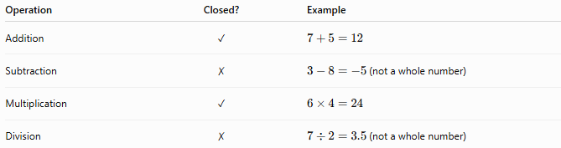
Operation | Closed? | Example
Addition | ✓ | $$7+5=12$$
Subtraction | ✗ | $3-8=-5$(not a whole number)
Multiplication | ✓ | $$6×4=24$$
Division | ✗ | $7÷2=3.5$(not a whole number)
Whole numbers are closed under addition and multiplication, but not under subtraction or division.

Properties of Whole Numbers

1. Closure Property
# Source: AI Source: Provided by: [Data Path: Persons Table -> ID Column: 1, Name_En Column: Motasem Essam] -> From: [ChatGPT] on [7/11/2026]
The sum or product of two whole numbers is always a whole number.
Examples:
$$8+5=13 \\ 6×7=42$$

2. Commutative Property
# Source: AI Source: Provided by: [Data Path: Persons Table -> ID Column: 1, Name_En Column: Motasem Essam] -> From: [ChatGPT] on [7/11/2026]
Changing the order does not affect the result.
Addition:
$$a+b=b+a$$
Example:
$$4+9=9+4$$
Multiplication:
$$a×b=b×a$$

3. Associative Property
# Source: AI Source: Provided by: [Data Path: Persons Table -> ID Column: 1, Name_En Column: Motasem Essam] -> From: [ChatGPT] on [7/11/2026]
Grouping does not affect the result.
Addition:
$$\left(a+b)+c=a+(b+c\right)$$
Multiplication:
$$\left(a×b)×c=a×(b×c\right)$$

4. Identity Property
# Source: AI Source: Provided by: [Data Path: Persons Table -> ID Column: 1, Name_En Column: Motasem Essam] -> From: [ChatGPT] on [7/11/2026]
Addition identity:
$$a+0=a$$
Multiplication identity:
$$a×1=a$$

5. Distributive Property
# Source: AI Source: Provided by: [Data Path: Persons Table -> ID Column: 1, Name_En Column: Motasem Essam] -> From: [ChatGPT] on [7/11/2026]
$$a(b+c)=ab+ac$$
Example:
$$5(3+2)=5×3+5×2=15+10=25$$

Examples
# Source: AI Source: Provided by: [Data Path: Persons Table -> ID Column: 1, Name_En Column: Motasem Essam] -> From: [ChatGPT] on [7/11/2026]
Example 1
Determine whether 18 is a whole number.
Solution:
18 is a nonnegative integer.
Answer: Yes.

Example 2
Determine whether −6 is a whole number.
Solution:
Whole numbers cannot be negative.
Answer: No.

Example 3
Determine whether 4.5 is a whole number.
Solution:
Whole numbers do not include decimals.
Answer: No.

Example 4
Evaluate:
$$12+9$$
Solution:
$$21$$
Since 21 is a whole number, the result remains in the set of whole numbers.

Real-Life Applications
# Source: AI Source: Provided by: [Data Path: Persons Table -> ID Column: 1, Name_En Column: Motasem Essam] -> From: [ChatGPT] on [7/11/2026]
Whole numbers are used for:
- Counting people
- Counting books
- Numbering houses
- Inventory management
- Population counts
- Scores in games
- Page numbers
- Product quantities

Whole Numbers vs. Natural Numbers
# Source: AI Source: Provided by: [Data Path: Persons Table -> ID Column: 1, Name_En Column: Motasem Essam] -> From: [ChatGPT] on [7/11/2026]
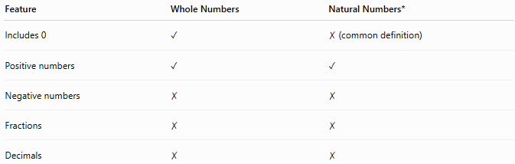
Feature | Whole Numbers | Natural Numbers*
Includes 0 | ✓ | ✗ (common definition)
Positive numbers | ✓ | ✓
Negative numbers | ✗ | ✗
Fractions | ✗ | ✗
Decimals | ✗ | ✗
* Some textbooks define natural numbers to include 0.

Key Points
# Source: AI Source: Provided by: [Data Path: Persons Table -> ID Column: 1, Name_En Column: Motasem Essam] -> From: [ChatGPT] on [7/11/2026]
- Whole numbers are 0 and all positive integers.
- The set of whole numbers is denoted by $W$.
- Whole numbers do not include negative numbers, fractions, or decimals.
- Whole numbers are closed under addition and multiplication.
- Zero is the smallest whole number.
- There is no largest whole number because the set is infinite.

Conclusion
# Source: AI Source: Provided by: [Data Path: Persons Table -> ID Column: 1, Name_En Column: Motasem Essam] -> From: [ChatGPT] on [7/11/2026]
Whole numbers are the nonnegative integers beginning with 0 and continuing indefinitely. They are fundamental in mathematics because they are used for counting, ordering, and representing quantities that cannot be negative. Whole numbers provide the foundation for arithmetic, algebra, and many practical applications in everyday life.

